📊 MASTER TABLE — VROC BREAKOUT / BREAKDOWN (WITH VALUES)

🧠 CORE IDEA (Numeric)
Item | Value | Meaning
VROC Threshold | 40% | Minimum participation
Stop Loss | −1% | Risk control
Target | +2% | Trend capture
Range Lookback | 5 ticks | Battle zone
VROC Lookback | 5 volumes | Volume speed

🟨 STAGE 1 — IDEA (VOLUME PRIMING)
🔢 Example Market Data
Tick | Price | Volume
1 | 885 | 900
2 | 886 | 1,100
3 | 884 | 1,400
4 | 886 | 1,800
5 | 885 | 2,200
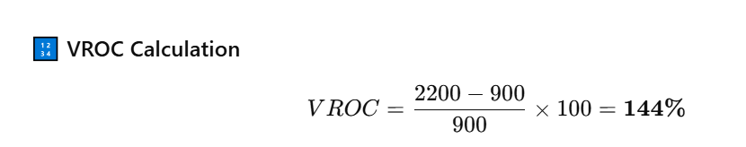

📋 IDEA STAGE TABLE
Parameter | Value | Algo Decision
VROC | 144% (> 40%) | ✅ Volume primed
Price Range High | 886 | Locked
Price Range Low | 884 | Locked
Direction | Unknown | ❌ No trade yet
State | PRIMED | Waiting
📌 Key Insight:
Price moved up & down, but algo did not care.

🟩 STAGE 2 — BREAKUP (LONG TRADE)
🔢 Price Action After Priming
Tick | Price
6 | 886
7 | 889 ← breakout

📋 BREAKUP TABLE (LONG)
Item | Value | Meaning
Break Level | > 886 | Range high
Entry Price | 889 | LONG entry
Stop Loss | 889 − 1% = 880.11 | Risk
Target | 889 + 2% = 906.78 | Reward
VROC | Ignored | Permission already given
📈 Action: LONG @ 889

🟥 STAGE 2 — BREAKDOWN (SHORT TRADE)
🔢 Alternate Scenario
Tick | Price
6 | 885
7 | 882 ← breakdown

📋 BREAKDOWN TABLE (SHORT)
Item | Value | Meaning
Break Level | < 884 | Range low
Entry Price | 882 | SHORT entry
Stop Loss | 882 + 1% = 890.82 | Risk
Target | 882 − 2% = 864.36 | Reward
VROC | Ignored | Permission already given
📉 Action: SHORT @ 882

🟥 STAGE 3 — EXIT (COMMON LOGIC)
📋 EXIT CONDITIONS WITH VALUES
Exit Type | Condition | Example | Result
Profit | +2% | 889 → 907 | ✅ Exit
VROC Reversal | VROC < 0 | 144% → −12% | 🔴 Exit
Stop Loss | −1% | 889 → 880 | ❌ Exit

